**PART B**

**AIM OF THE PROJECT : Micro-project on Book Shop Management System**

**Brief Description :**

* The project helps us to access some vital working process of a certain bookshop.
* Its helps the customers to become a member of bookshop ,without the need of visiting the bookshop and filling various form.
* It helps the staff to check the avability of certain book using computerized data stored about the book.
* The project has facility the member to check their book purchases and sales done with the book shop and also provides them essential information about their membership.
* The project is fully secured with password/pin to access the member,staff,adminstrator account .

**Aim of micro project :**

The micro-project aims at:-

* By using ‘c++’ language application & software can be more easily developed.
* Detail study of each concept of ‘c++’ language like class, etc.
* To make some process of bookshop flexible for customer,staff.
* Reduces time, effort and manual work.
* Provide variousefacility such as “book purchased””checkavability of books” “membership information”,etc through the project.
* Also provides facilities of totaling of purchased books.

**Course Outcome integrated :**

* Implement inheritance in C++ Program
* Develop C++ program using Classes and Objects
* Develop C++ programs to solve problems using Procedure Oriented Approach

**Actual procedure followed :**

1. **Group Formation:-** OOP is subject which teaches us some important C++ function .The basic aim of micro- project is to accelerate the attainment of the variouse outcome in the course.In the first 2 weeks of August the subject was introduced .The syllabus as well as detail of micro-project was discussed.The group of 3members were formed and the group leaders were selected.The schedule of Plan “A”,”B”& “PRESENTATION” were finalized.The variouse micro-project topics related to subject was discussed our guide gave us the opportunity to select the topic of our choice.
2. **Finalization Of Micro-Project:-**After attending the lectures for 2 weeks.We selected the topic for micro-project.We discussed the topic with our Guide regarding the concept which we are going to apply in the project.We individually tried to explain the basic platformof project.
3. **Planning:-** After finalization of the project we started working on the project.we started the planning phase.We discussed among ourselves regarding the resources such as software requirements,compiler.In this week we completed ‘PART A PLAN’ of the micro-project which is nothing but a initial description about the project.We submitted it to the guide.
4. **Module Distribution &Analysis Part:-** Once the planning was over regarding resource’s etc..According to members we distributed the module among us .We started the analysis of project.
5. **Design Part :-** In this part we added some graphics function to our micro-project . With the help of this our project got a new look.
6. **Implementation :-** In the week we actually started the technical phase .The coding for each module was done each member was writing code according to module assighned to them.the testing of code was done to achieve the requirementof project.finally the project was within the schedule time.
7. **Presentation :-**In this week we have to present the micro-project in front of the guide.Each member of group presented their own parts with confidence in front of guide.She asked us variouse queries regarding the topics.We presented the details of each concept of the graphics functions that we used in the project. She asked us to do variouse changes regarding some topics.
8. **Submission:-**This week was submission week.We submitted our project along with ‘Part A & B Plan’ to the guide.We also submitted the hard copies and soft copies of project to the guide

**Actual resources used :**

|  |  |  |  |  |
| --- | --- | --- | --- | --- |
| SR NO | NAME OF RESOURCES USED | SPECIFICATION | QUANTITY | REMARKS |
| 1 | COMPUTER | **PROCESSOR**-AMD  **HARD DISK-**2 TB  **RAM**-16GB  **OPERATING SYSTEM**-WINDOWS 10 PRO | 1  1  1  1 | HARDWARE & SOFTWARE USED |
| 2 | TURBO C | TURBO 4.0 |  | IDE &COMPILER FOR C PROGRAMMING |
| 3 | PROGRAMMING LANGUAGE | C++ |  | PROGRAMMING LANGUAGE |

**Output of the micro project :**

The output of the project is according to following index :

|  |  |
| --- | --- |
| SR NO | CONTENT |
| 1 | CODING |
| 2 | CODE OUTPUT |
| 3 | REFERENCES |

**CODING**

#include<iostream.h>

#include<conio.h>

#include<string.h>

#include<stdio.h>

#include<graphics.h>

class member1

{

public:

void display();

};

void member1::display()

{

cout<<"********************************************************************************"<<endl;

cout<<"\n\tNAME:\t\t\t"<<"HERAMB RAMAKANT PAWAR";

cout<<"\n\n\tCONTACT NUMBER:\t\t"<<"9967252861";

cout<<"\n\n\tEMAIL ADDRESS:\t\t"<<"herambpawar1307@gmail.com";

cout<<"\n\n\tBIRTH PLACE:\t\t"<<"THANE";

cout<<"\n\n\tMEMBERSHIP TYPE:\t"<<"PREMIUM";

cout<<"\n\n\tLAST RENEWED:\t\t"<<"11:11:11";

cout<<"\n\n\tRENEWAL EXPIRES ON:\t"<<"12:11:11";

cout<<"\n\n\tRENEWAL AMOUNT:\t\t"<<"1200.RS";

cout<<"\n\n********************************************************************************";

}

class member2

{

public:

void display();

};

void member2::display()

{

cout<<"\n****************************************************************************";

cout<<"\n\n\tNAME:\t\t\t"<<"VARUN VIJAY CHAUDARY";

cout<<"\n\n\tCONTACT NUMBER:\t\t"<<"";

cout<<"\n\n\tEMAIL ADDRESS:\t\t"<<"";

cout<<"\n\n\tBIRTH PLACE:\t\t"<<"BHIWANDI";

cout<<"\n\n\tMEMBERSHIP TYPE:\t"<<"GOLD";

cout<<"\n\n\tLAST RENEWED:\t\t"<<"3:3:3";

cout<<"\n\n\tRENEWAL EXPIRES ON:\t"<<"4:3:4";

cout<<"\n\n\tRENEWAL AMOUNT:\t\t"<<"500.RS";

cout<<"\n\n***************************************************************************\n";

}

class member3

{

public:

void display();

};

void member3::display()

{

cout<<"\n\n******************************************************************************";

cout<<"\n\n\tNAME:\t\t\t"<<"DRAVIN CHAUHAN";

cout<<"\n\n\tCONTACT NUMBER:\t\t"<<"";

cout<<"\n\n\tEMAIL ADDRESS:\t\t"<<"";

cout<<"\n\n\tBIRTH PLACE:\t\t"<<"KALYAN";

cout<<"\n\n\tMEMBERSHIP TYPE:\t"<<"BASIC";

cout<<"\n\n\tLAST RENEWED:\t\t"<<"1:11:1";

cout<<"\n\n\tRENEWAL EXPIRES ON:\t"<<"2:11:2";

cout<<"\n\n\tRENEWAL AMOUNT:\t\t"<<"200.RS";

cout<<"\n\n******************************************************************************\n";

}

class signup

{

char name[50];

long number;

char email[50];

char birthplace[10];

public:

void getdata();

void displaydata();

};

void signup::getdata()

{

cout<<"\tENTER YOUR NAME <ONLY FIRST NAME>:\t";

cin>>name;

cout<<"\n";

cout<<"\tENTER YOUR CONTACT NUMBER:\t\t";

cin>>number;

cout<<"\n";

cout<<"\tENTER YOUR EMAIL ID:\t\t\t";

cin>>email;

cout<<"\n";

cout<<"\tENTER YOUR BIRTH PLACE:\t\t\t";

cin>>birthplace;

}

void signup::displaydata()

{

cout<<"\tNAME:\t\t"<<name<<"\n";

cout<<"\tNUMBER:\t\t"<<number<<"\n";

cout<<"\tEMAIL ID:\t"<<email<<"\n";

cout<<"\tBIRTH PLACE:\t"<<birthplace<<"\n";

}

class books

{

public:

void pdisplay();

void sdisplay();

};

class book1 :public books

{

public:

void pdisplay();

void sdisplay();

};

class book2 :public books

{

public:

void pdisplay();

void sdisplay();

};

class books4 :public books

{

public:

void display()

{

cout<<"\n\t1.WONDER\t";

cout<<"\n\t2.THE LITTLE PRINCE\t";

cout<<"\n\t3.PETER AND WENDY\t";

cout<<"\n\t4.THE GIVING TREE\t";

cout<<"\n\t5.BLACK BEAUTY";

cout<<"\n\t6.CHICA CHICA BOOM BOOM";

cout<<"\n\t7.THE VERY HUNGRY\t";

cout<<"\n\t8.GOODNIGHT MOON\t";

cout<<"\n\t9.CHARLOTTE'S WEB\t";

}

};

void book2::pdisplay()

{

cout<<"\n\tWONDER\t"<<"\t\t100\t"<<" 1:1:1";

cout<<"\n\tTHE LITTLE PRINCE\t"<<"1000\t"<<" 5:11:1";

cout<<"\n\tPETER AND WENDY\t"<<"\t160\t"<<" 4:1:1";

}

void book2::sdisplay()

{

cout<<"\n\tTHE GIVING TREE\t"<<"\t100\t"<<" 13:12:13";

cout<<"\n\tBLACK BEAUTY\t"<<"\t1000\t"<<" 5:11:15";

cout<<"\n\tCHICA CHICA BOOM BOOM\t"<<"160\t"<<" 4:10:1";

}

void book1::pdisplay()

{

cout<<"\n\tTHE VERY HUNGRY\t"<<"\t100\t"<<" 1:12:12";

cout<<"\n\tGOODNIGHT MOON\t"<<"\t1000\t"<<" 5:1:15";

cout<<"\n\tCHARLOTTE'S WEB\t"<<"\t160\t"<<" 4:11:1";

}

void book1::sdisplay()

{

cout<<"\n\tDOG MAN\t"<<"\t100\t"<<" 1:12:12";

cout<<"\n\tTHE HOBBIT\t"<<"1000\t"<<" 5:1:15";

cout<<"\n\tMATILDA\t"<<"\t160\t"<<" 4:11:1";

}

void books::pdisplay()

{

cout<<"\n\tTHE POWER OF THINKING\t"<<"1200\t"<<" 12:12:12";

cout<<"\n\tPUBLIC SPEAKING\t"<<"\t1300\t"<<" 15:12:15";

cout<<"\n\tPRIDE& PREJUDICE\t"<<"1600\t"<<" 14:11:14";

}

void books::sdisplay()

{

cout<<"\n\tTWILIGHT\t"<<"500\t"<<" 12:1:12";

cout<<"\n\tATLANTA NIGHTS\t"<<"200\t"<<" 15:7:15";

cout<<"\n\tEYE OF ARGON\t"<<"800\t"<<" 16:5:14";

}

void main()

{

loop:

clrscr();

int gd=DETECT,gm;

initgraph(&gd,&gm,"\\turboc3\\bgi");

setcolor(BLUE);

settextstyle(10,0,4);

cout<<"\t\t\t";

outtextxy(9,12,"CRAZY WISDOM BOOKS");

setcolor(12);

line(10,90,1000,90);

int n,a,b,c,d,e,f,g,h,k,number,i,bid,cost[10],sum=0,sum1=0;

char name[20];

cout<<"\n\n\n\n\n\n\n\t\t\tWELCOME TO CRAZY WISDOM BOOKSTORE";

cout<<"\n\n\n\n";

cout<<"\tPLEASE SELECT A OPTION";

cout<<"\n\n";

cout<<"\t1. MEMBER LOGIN\n\t2. STAFF LOGIN\n\t3. SIGNUP/CREATE ACCOUNT\n\n";

cout<<"\tENTER THE OPTION SELECTED:\t\t";

cin>>n;

cout<<endl;

switch (n)

{

case 1:

cout<<"-x-x-x-x-x-x-x-x-x-x-x-x-x-x-x-x-x-x-x-x-x-x-x-x-x-x-x-x-x-x-x-x-x-x-x-x-x-x-x-\n\n";

cout<<"\tPLEASE ENTER YOUR MEMBER/LOGIN ID:\t";

cin>>a;

cout<<"\tPLEASE ENTER YOUR PASSWORD:\t\t";

cin>>b;

if(a==2217&&b==1234)

{

cout<<"-x-x-x-x-x-x-x-x-x-x-x-x-x-x-x-x-x-x-x-x-x-x-x-x-x-x-x-x-x-x-x-x-x-x-x-x-x-x-x-\n\n";

cout<<"\t\t\t WELCOME HERAMB RAMAKANT PAWAR\n";

cout<<"_______________________________________________________________________________\n\n";

cout<<"\n\n";

cout<<"\tPLEASE SELECT A OPTION:\n\n";

cout<<"\t1. BOOKS PURCHASED"<<endl<<"\t2. BOOKS SOLD"<<endl<<"\t3. MEMBERSHIP INFORMATION"<<endl;

cout<<"\n\tENTERED THE SELECTED OPTION:\t";

cin>>c;

switch(c)

{

case 1:

cout<<"\nx-x-x-x-x-x-x-x-x-x-x-x-x-x-x-x-x-x-x-x-x-x-x-x-x-x-x-x-x-x-x-x-x-x-x-x-x-x-x-x-";

cout<<"\n\tBOOK NAME\t\t"<<"COST\t"<<"DATE OF PURCHASE\n";

books b;

cout<<"\t";

b.pdisplay();

cout<<"\n\nx-x-x-x-x-x-x-x-x-x-x-x-x-x-x-x-x-x-x-x-x-x-x-x-x-x-x-x-x-x-x-x-x-x-x-x-x-x-x-x-";

break;

case 2:

cout<<"\nx-x-x-x-x-x-x-x-x-x-x-x-x-x-x-x-x-x-x-x-x-x-x-x-x-x-x-x-x-x-x-x-x-x-x-x-x-x-x-x-";

cout<<"\n\tBOOK NAME\t"<<"REFUND\t"<<"DATE OF SELLING\n";

books a;

cout<<"\t";

a.sdisplay();

cout<<"\n\nx-x-x-x-x-x-x-x-x-x-x-x-x-x-x-x-x-x-x-x-x-x-x-x-x-x-x-x-x-x-x-x-x-x-x-x-x-x-x-x-";

break;

case 3:

cout<<"\n________________________________________________________________________________";

cout<<"\n\t\t\tYOUR MEMBERSHIP INFORMATION IS AS FOLLOWS ";

cout<<"\n________________________________________________________________________________";

member1 m;

m.display();

cout<<"\n________________________________________________________________________________";

break;

default:

cout<<"\n________________________________________________________________________________";

cout<<"\n\t\tPLEASE ENTER A VALID OPTION";

cout<<"\n________________________________________________________________________________";

}

cout<<"\n\tWHAT WOULD YOU LIKE TO DO NOW:\n\n";

cout<<"\n\t1.GO TO MAINPAGE";

cout<<"\n\t2.QUIT";

cout<<"\n\t\t ENTER A VALID CHOICE:\t";

cin>>d;

if(d==1)

{

goto loop;

}

if(d==2)

{

cout<<"\n\n____________________________________________________________________________";

cout<<"\t\n\n\t\t\tTHANK YOU FOR USING OUR SERVICE";

}

else

{

cout<<"\n\t\t\t ENTER A VALID CHOICE";

getch();

}

}

else if(a==3337&&b==5678)

{

cout<<"-x-x-x-x-x-x-x-x-x-x-x-x-x-x-x-x-x-x-x-x-x-x-x-x-x-x-x-x-x-x-x-x-x-x-x-x-x-x-x-\n\n";

cout<<"\t\t\t WELCOME VARUN VIJAY CHAUDARY\n";

cout<<"_______________________________________________________________________________\n\n";

cout<<"\n\n";

cout<<"\tPLEASE SELECT A OPTION:\n\n";

cout<<"\t1. BOOKS PURCHASED"<<endl<<"\t2. BOOKS SOLD"<<endl<<"\t3. MEMBERSHIP INFORMATION"<<endl;

cout<<"\n\tENTERED THE SELECTED OPTION:\t";

cin>>c;

switch(c)

{

case 1:

{

cout<<"\nx-x-x-x-x-x-x-x-x-x-x-x-x-x-x-x-x-x-x-x-x-x-x-x-x-x-x-x-x-x-x-x-x-x-x-x-x-x-x-x-";

cout<<"\n\tBOOK NAME\t\t"<<"COST\t"<<"DATE OF PURCHASE\n";

book1 b;

cout<<"\t";

b.pdisplay();

cout<<"\nx-x-x-x-x-x-x-x-x-x-x-x-x-x-x-x-x-x-x-x-x-x-x-x-x-x-x-x-x-x-x-x-x-x-x-x-x-x-x-x-";

}

break;

case 2:

cout<<"\nx-x-x-x-x-x-x-x-x-x-x-x-x-x-x-x-x-x-x-x-x-x-x-x-x-x-x-x-x-x-x-x-x-x-x-x-x-x-x-x-";

cout<<"\n\tBOOK NAME\t"<<"REFUND\t"<<"DATE OF SELLING\n";

book1 a;

cout<<"\t";

a.sdisplay();

cout<<"\n\nx-x-x-x-x-x-x-x-x-x-x-x-x-x-x-x-x-x-x-x-x-x-x-x-x-x-x-x-x-x-x-x-x-x-x-x-x-x-x-x-";

break;

case 3:

cout<<"\n________________________________________________________________________________";

cout<<"\n\t\tYOUR MEMBERSHIP INFORMATION IS AS FOLLOWS ";

cout<<"\n________________________________________________________________________________";

member2 e;

e.display();

cout<<"\n________________________________________________________________________________";

break;

default:

cout<<"\n________________________________________________________________________________";

cout<<"\n\t\t\tPLEASE ENTER A VALID OPTION";

cout<<"\n________________________________________________________________________________";

}

cout<<"\n\tWHAT WOULD YOU LIKE TO DO NOW:\n\n";

cout<<"\n\t1.GO TO MAINPAGE";

cout<<"\n\t2.QUIT";

cout<<"\n\n\t\t ENTER YOUR VALID CHOICE:\t";

cin>>d;

if(d==1)

{

goto loop;

}

if(d==2)

{

cout<<"\n\n____________________________________________________________________________";

cout<<"\n\n\t\t\tTHANK YOU FOR USING OUR SERVICE";

}

else

{

cout<<"\n\t\t\t ENTER A VALID CHOICE";

getch();

}

}

else if(a==1117&&b==9101)

{

cout<<"-x-x-x-x-x-x-x-x-x-x-x-x-x-x-x-x-x-x-x-x-x-x-x-x-x-x-x-x-x-x-x-x-x-x-x-x-x-x-x-\n\n";

cout<<"\t\t\t WELCOME DRAVIN CHAUAN \n";

cout<<"_______________________________________________________________________________\n\n";

cout<<"\n\n";

cout<<"\tPLEASE SELECT A OPTION:\n\n";

cout<<"\t1. BOOKS PURCHASED"<<endl<<"\t2. BOOKS SOLD"<<endl<<"\t3. MEMBERSHIP INFORMATION"<<endl;

cout<<"\n\tENTERED THE SELECTED OPTION:\t";

cin>>c;

switch(c)

{

case 1:

cout<<"\nx-x-x-x-x-x-x-x-x-x-x-x-x-x-x-x-x-x-x-x-x-x-x-x-x-x-x-x-x-x-x-x-x-x-x-x-x-x-x-x-";

cout<<"\n\tBOOK NAME\t\t"<<"COST\t"<<"DATE OF PURCHASE\n";

book2 b;

cout<<"\t";

b.pdisplay();

cout<<"\n\nx-x-x-x-x-x-x-x-x-x-x-x-x-x-x-x-x-x-x-x-x-x-x-x-x-x-x-x-x-x-x-x-x-x-x-x-x-x-x-x-";

break;

case 2:

cout<<"\nx-x-x-x-x-x-x-x-x-x-x-x-x-x-x-x-x-x-x-x-x-x-x-x-x-x-x-x-x-x-x-x-x-x-x-x-x-x-x-x-";

cout<<"\n\tBOOK NAME\t"<<"\tREFUND\t"<<"DATE OF SELLING\n";

book2 a;

cout<<"\t";

a.sdisplay();

cout<<"\n\nx-x-x-x-x-x-x-x-x-x-x-x-x-x-x-x-x-x-x-x-x-x-x-x-x-x-x-x-x-x-x-x-x-x-x-x-x-x-x-x-";

break;

case 3:

cout<<"\n________________________________________________________________________________";

cout<<"\n\t\tYOUR MEMBERSHIP INFORMATION IS AS FOLLOWS ";

cout<<"\n________________________________________________________________________________";

member3 p;

p.display();

cout<<"\n________________________________________________________________________________";

break;

default:

cout<<"\n________________________________________________________________________________";

cout<<"\t\t\tPLEASE ENTER A VALID OPTION";

cout<<"\n________________________________________________________________________________";

}

cout<<"\n\tWHAT WOULD YOU LIKE TO DO NOW:\n\n";

cout<<"\n\t1.GO TO MAINPAGE";

cout<<"\n\t2.QUIT";

cout<<"\n\n\t ENTER A VALID CHOICE:\t";

cin>>d;

if(d==1)

{

goto loop;

}

if(d==2)

{

cout<<"\n\n____________________________________________________________________________";

cout<<"\n\n\t\t\tTHANK YOU FOR USING OUR SERVICE";

}

else

{

cout<<"\n\t\t\t ENTER A VALID CHOICE";

getch();

}

}

else

{

cout<<"\n\n";

cout<<"\t\t\tPLEASE ENTER VALID CREDENTIALS";

getch();

}

break;

case 2:

cout<<"********************************************************************************";

cout<<"\n\t PLEASE ENTER YOUR STAFF ID :\t";

cin>>e;

cout<<"\n\t PLEASE ENTER YOUR PASSWORD :\t";

cin>>f;

cout<<"********************************************************************************";

if(e==1117&&f==1234)

{

cout<<"\n\n\t\t\t\t WELCOME STAFF 1";

cout<<"\n\n################################################################################";

cout<<"\n\n\n";

cout<<"\tPLEASE SELECT A OPTION:";

cout<<"\n\n\n\t 1.CHECK AVABILITY OF BOOKS";

cout<<"\n\t 2.FIND LOCATION OF BOOKS";

cout<<"\n\t 3.PAYMENT COUNTER";

cout<<"\n\n\n\tENTER YOUR OPTION:\t";

cin>>g;

cout<<"\n################################################################################";

switch(g)

{

case 1:

cout<<"\n\n\n\tPLEASE SELECT THE BOOK FROM GIVEN LIST:\n\n";

books4 m;

m.display();

cout<<"\n\n\n\tPLEASE ENTER THE BOOK NUMBER:\t";

cin>>g;

cout<<"********************************************************************************";

if(g==1,g==2,g==3,g==4,g==5)

{

cout<<"\n\t\t\t THE FOLLOWING BOOK IS IN STOCK";

cout<<"\n******************************************************************************";

}

else

{

cout<<"\n\t\t\t THE FOLLOWING BOOK IS NOT IN STOCK";

cout<<"\n*******************************************************************************";

}

cout<<"\n\tWHAT WOULD YOU LIKE TO DO NOW:\n\n";

cout<<"\n\t1.GO TO MAINPAGE";

cout<<"\n\t2.QUIT";

cout<<"\n\n\t ENTER A VALID CHOICE:\t";

cin>>d;

if(d==1)

{

goto loop;

}

if(d==2)

{

cout<<"\n\n____________________________________________________________________________";

cout<<"\n\n\t\t\tTHANK YOU FOR USING OUR SERVICE";

}

else

{

cout<<"\n\t\t\t ENTER A VALID CHOICE";

getch();

}

break;

case 2:

cout<<"\n\tPLEASE SELECT FROM THE GIVEN LIST OF BOOK:";

cout<<"\n\n\t1.WONDER\t";

cout<<"\n\t2.THE LITTLE PRINCE\t";

cout<<"\n\t3.PETER AND WENDY\t";

cout<<"\n\t4.THE GIVING TREE\t";

cout<<"\n\t5.BLACK BEAUTY";

cout<<"\n\n\t PLEASE ENTER THE NUMBER:\t";

cin>>k;

switch(k)

{

case 1:

cout<<"\n\t\t\tTHE BOOK IS IN 2nd RACK AT LEVEL 2";

break;

case 2:

cout<<"\n\t\t\tTHE BOOK IS IN 1st RACK AT LEVEL 1";

break;

case 3:

cout<<"\n\t\t\tTHE BOOK IS IN 5th RACK AT LEVEL 3";

break;

case 4:

cout<<"\n\t\t\tTHE BOOK IS IN 3rd RACK AT LEVEL 1";

break;

case 5:

cout<<"\n\t\t\tTHE BOOK IS IN 1st RACK AT LEVEL 4";

break;

default:

cout<<"\t\t\t ENTER VALID OPTION";

break;

}

cout<<"\n\tWHAT WOULD YOU LIKE TO DO NOW:\n\n";

cout<<"\n\t1.GO TO MAINPAGE";

cout<<"\n\t2.QUIT";

cout<<"\n\t\t ENTER A VALID CHOICE:\t";

cin>>d;

if(d==1)

{

goto loop;

}

if(d==2)

{

cout<<"\n\n____________________________________________________________________________";

cout<<"\t\n\n\t\t\tTHANK YOU FOR USING OUR SERVICE";

}

else

{

cout<<"\n\t\t\t ENTER A VALID CHOICE";

getch();

}

break;

case 3:

cout<<"\n\n\tENTER NUMBER OF BOOKS:\t";

cin>>number;

for(i=0;i<number;i++)

{

cout<<"\n\n********************************************************************************";

cout<<"\n\n\tENTER BOOK NAME:\t";

cin>>name;

cout<<"\n\tENTER BOOK ID:\t\t";

cin>>bid;

cout<<"\n\tENTER COST:\t\t";

cin>>cost[i];

}

for(i=0;i<number;i++)

{

sum=sum+cost[i];

}

cout<<"\n\n********************************************************************************";

cout<<"\n\n\t\t\tYOUR TOTAL IS:\t"<<sum;

cout<<"\n\n********************************************************************************";

cout<<"\n\t\t\tTHANKYOU FOR USING THE SERVICE";

getch();

break;

default:

cout<<"\n\n\t\t\t PLEASE ENTER VALID OPTION";

getch();

}

cout<<"\n\tWHAT WOULD YOU LIKE TO DO NOW:\n\n";

cout<<"\n\t1.GO TO MAINPAGE";

cout<<"\n\t2.QUIT";

cout<<"\n\t\t ENTER A VALID CHOICE:\t";

cin>>d;

if(d==1)

{

goto loop;

}

if(d==2)

{

cout<<"\n\n____________________________________________________________________________";

cout<<"\t\n\n\t\t\tTHANK YOU FOR USING OUR SERVICE";

}

else

{

cout<<"\n\t\t\t ENTER A VALID CHOICE";

}

getch();

break;

}

if(e==2217&&f==5678)

{

cout<<"\n\n\t\t\t\t WELCOME STAFF 2";

cout<<"\n\n################################################################################";

cout<<"\n\n\n";

cout<<"\tPLEASE SELECT A OPTION:";

cout<<"\n\n\n\t 1.CHECK AVABILITY OF BOOKS";

cout<<"\n\t 2.FIND LOCATION OF BOOKS";

cout<<"\n\t 3.PAYMENT COUNTER";

cout<<"\n\n\n\tENTER YOUR OPTION:\t";

cin>>g;

cout<<"\n################################################################################";

switch(g)

{

case 1:

cout<<"\n\n\n\tPLEASE SELECT THE BOOK FROM GIVEN LIST:\n\n";

books4 m;

m.display();

cout<<"\n\n\n\tPLEASE ENTER THE BOOK NUMBER:\t";

cin>>g;

cout<<"********************************************************************************";

if(g==1,g==2,g==3,g==4,g==5)

{

cout<<"\n\t\t THE FOLLOWING BOOK IS IN STOCK";

cout<<"\n*******************************************************************************";

}

else

{

cout<<"\n\t\t THE FOLLOWING BOOK IS NOT IN STOCK";

cout<<"\n******************************************************************************";

}

cout<<"\n\n\tWHAT WOULD YOU LIKE TO DO NOW:\n\n";

cout<<"\n\t1.GO TO MAINPAGE";

cout<<"\n\t2.QUIT";

cout<<"\n\n\t ENTER A VALID CHOICE:\t";

cin>>d;

if(d==1)

{

goto loop;

}

else if(d==2)

{

cout<<"\n\n____________________________________________________________________________";

cout<<"\n\n\t\t\tTHANK YOU FOR USING OUR SERVICE";

}

else

{

cout<<"\n\t\t\t ENTER A VALID CHOICE";

getch();

}

break;

case 2:

cout<<"\n\tPLEASE SELECT FROM THE GIVEN LIST OF BOOK:";

cout<<"\n\n\t1.WONDER\t";

cout<<"\n\t2.THE LITTLE PRINCE\t";

cout<<"\n\t3.PETER AND WENDY\t";

cout<<"\n\t4.THE GIVING TREE\t";

cout<<"\n\t5.BLACK BEAUTY";

cout<<"\n\n\t PLEASE ENTER THE NUMBER:\t";

cin>>k;

switch(k)

{

case 1:

cout<<"\n\t\t\tTHE BOOK IS IN 2nd RACK AT LEVEL 2";

break;

case 2:

cout<<"\n\t\t\tTHE BOOK IS IN 1st RACK AT LEVEL 1";

break;

case 3:

cout<<"\n\t\t\tTHE BOOK IS IN 5th RACK AT LEVEL 3";

break;

case 4:

cout<<"\n\t\t\tTHE BOOK IS IN 3rd RACK AT LEVEL 1";

break;

case 5:

cout<<"\n\t\t\tTHE BOOK IS IN 1st RACK AT LEVEL 4";

break;

default:

cout<<"\t\t\t ENTER VALID OPTION";

break;

}

getch();

cout<<"\n\tWHAT WOULD YOU LIKE TO DO NOW:\n\n";

cout<<"\n\t1.GO TO MAINPAGE";

cout<<"\n\t2.QUIT";

cout<<"\n\t\t ENTER A VALID CHOICE:\t";

cin>>d;

if(d==1)

{

goto loop;

}

else if(d==2)

{

cout<<"\n\n____________________________________________________________________________";

cout<<"\t\n\n\t\t\tTHANK YOU FOR USING OUR SERVICE";

}

else

{

cout<<"\n\t\t\t ENTER A VALID CHOICE";

}

break;

case 3:

cout<<"\n\n\tENTER NUMBER OF BOOKS:\t";

cin>>number;

for(i=0;i<number;i++)

{

cout<<"\n\n********************************************************************************";

cout<<"\n\n\tENTER BOOK NAME:\t";

cin>>name;

cout<<"\n\tENTER BOOK ID:\t\t";

cin>>bid;

cout<<"\n\tENTER COST:\t\t";

cin>>cost[i];

}

for(i=0;i<number;i++)

{

sum1=sum1+cost[i];

}

cout<<"\n\n********************************************************************************";

cout<<"\n\n\t\t\tYOUR TOTAL IS:\t"<<sum1;

cout<<"\n\n********************************************************************************";

cout<<"\n\t\t\tTHANKYOU FOR USING THE SERVICE";

cout<<"\n\n********************************************************************************";

getch();

break;

default:

cout<<"\n\n\t\t\t PLEASE ENTER VALID OPTION";

getch();

}

cout<<"\n\n\tWHAT WOULD YOU LIKE TO DO NOW:\n\n";

cout<<"\n\t1.GO TO MAINPAGE";

cout<<"\n\t2.QUIT";

cout<<"\n\t\t ENTER A VALID CHOICE:\t";

cin>>d;

if(d==1)

{

goto loop;

}

else if(d==2)

{

cout<<"\n\n____________________________________________________________________________";

cout<<"\t\n\n\t\t\tTHANK YOU FOR USING OUR SERVICE";

}

else

{

cout<<"\n\t\t\t ENTER A VALID CHOICE";

getch();

}

}

break;

case 3:

cout<<"\n";

cout<<"_______________________________________________________________________________\n\n";

cout<<"\t WELCOME TO CRAZY WISDOM LETS BECOME A ONE FAMILY!!\n\n";

cout<<"_______________________________________________________________________________\n\n";

cout<<"\n\tPLEASE ENTER A VALID DATA:\n\n";

signup s;

s.getdata();

cout<<"\n\n\tYOUR ACCOUNT WAS CREATED SUCCESSFULLY\n\tPLEASE CHECK YOUR DETAILS BELOW\n";

cout<<"________________________________________________________________________________\n\n";

cout<<"\tACCOUNT DETAILS ENTERED:\n\n";

s.displaydata();

cout<<"\n\n";

cout<<"________________________________________________________________________________\n";

cout<<"\n\tNOTE:DEAR USER IF THE DATA ENTERED IS INCORRECT.YOU WILL NEED TO REFILL \tTHE SIGNUP FORM OR WILL NEED TO VISIT OUR NEAREST BRANCH.INCONVINENCE \n\tREGRETED.\n\n";

cout<<"________________________________________________________________________________\n";

cout<<"\n\tWHAT WOULD YOU LIKE TO DO NOW:\n\n";

cout<<"\t1.GO TO MAINPAGE";

cout<<"\n\t2.QUIT";

cout<<"\n\n\t ENTER YOUR CHOICE:\t";

cin>>d;

if(d==1)

{

goto loop;

}

else if(d==2)

{

cout<<"\n\n____________________________________________________________________________";

cout<<"\n\n\t\t\tTHANK YOU FOR USING OUR SERVICE";

getch();

}

else

{

cout<<"\n\t\t\t\tENTER VALID OPTION";

getch();

}

break;

default:

cout<<"\n\t\t\t\tENTER VALID OPTIONS";

getch();

break;

}

closegraph();

}

**CODE OUTPUT**

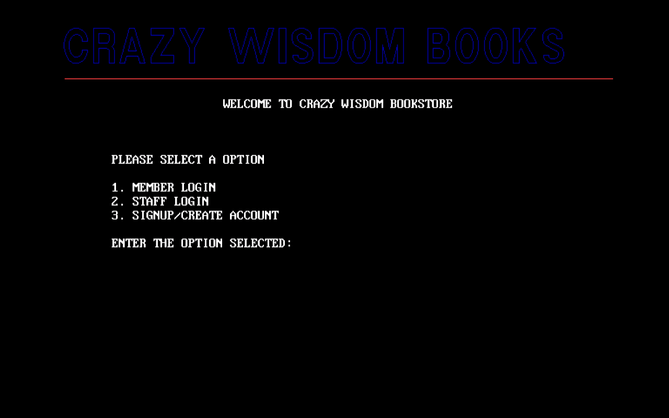

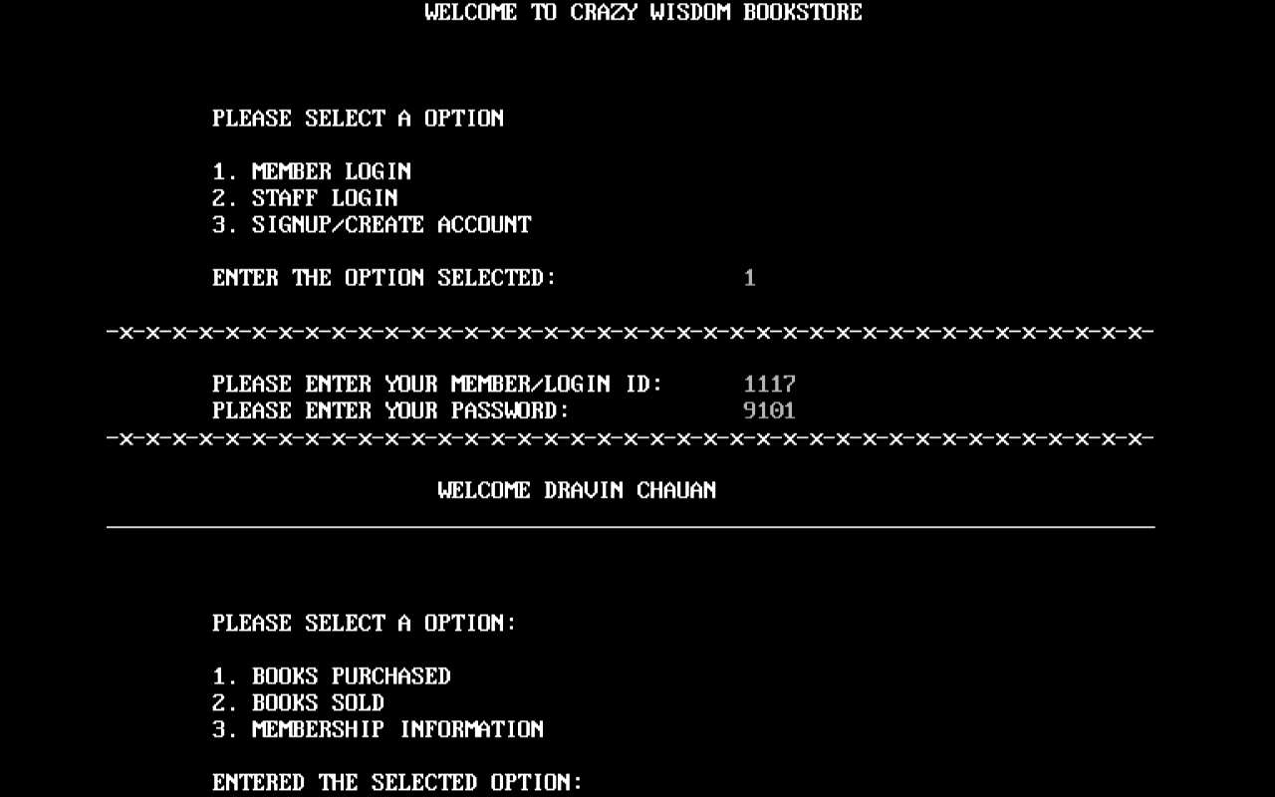

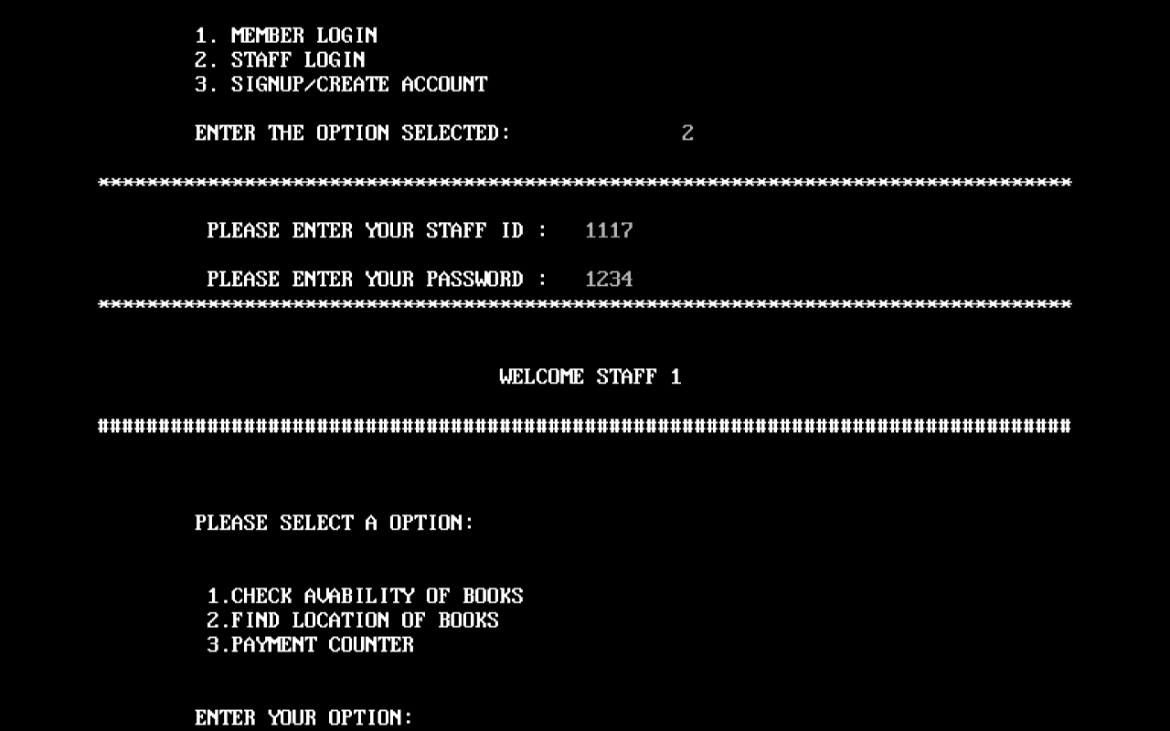

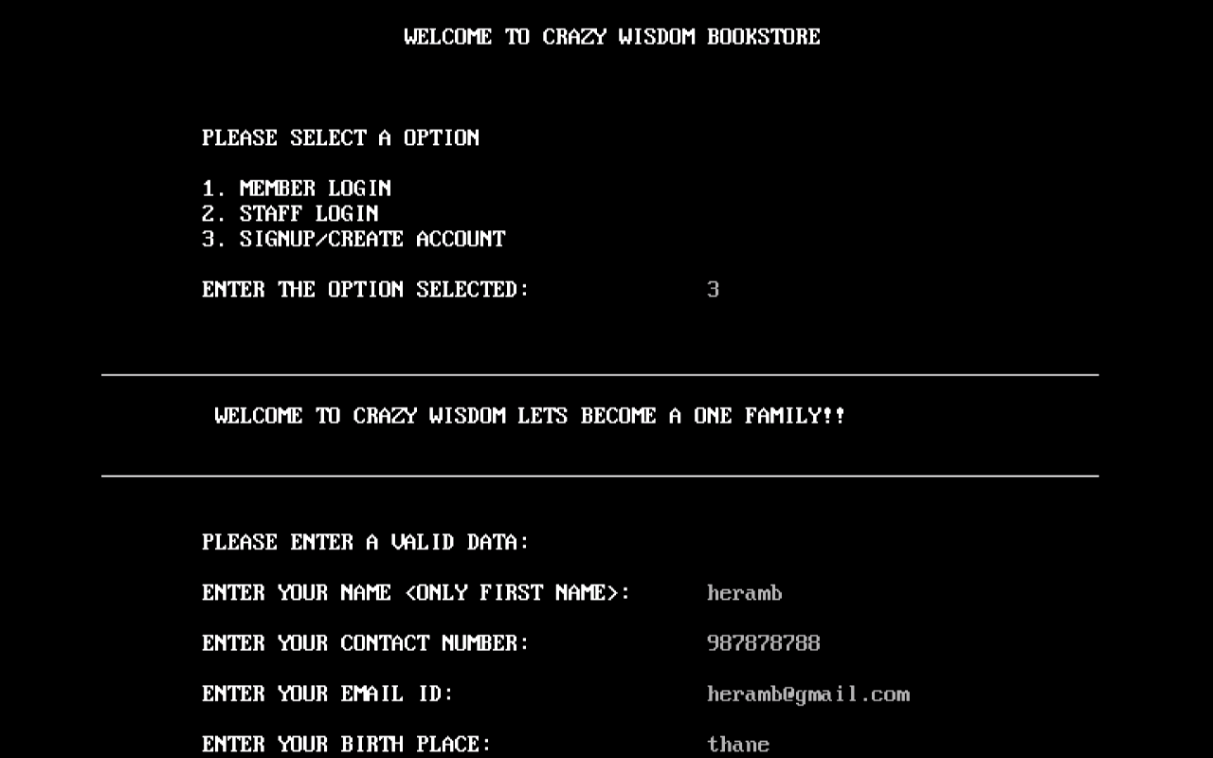

**REFERENCES**

We do have used a few references during the process of building our project. The references used are from Websites, Books etc.

The references used are:

WEBSITES:

1: www.programiz.com.

2: www.tutorialspoint.com.

3: www.quora.com.

REFERENCE BOOKS:

1: The C++ Programing Language By Stroutstup.B

2: C++ Programing By Dr. Rajendra Kawale

**Skill developed/learning out of this micro project :**

* Since we worked in a group,We developed the skill of ‘TEAMWORK’ in us
* We came to know how and when to use some of the important concept ofc++.
* We attained the satisfied level of programming